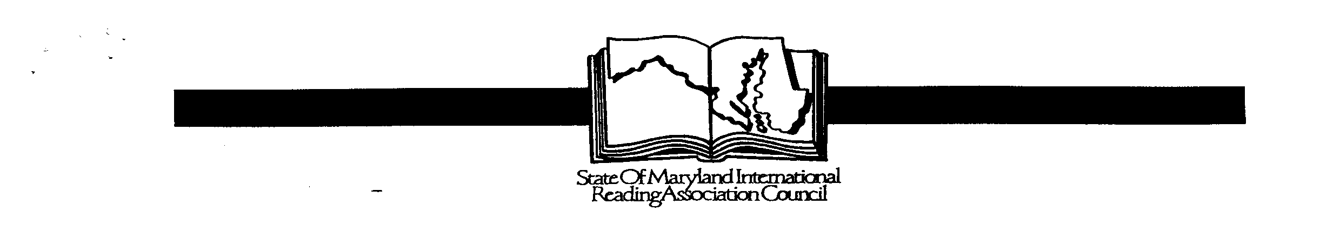

YOUNG AUTHORS’ CONTEST SoMLA 2018-2019

COVER SHEET

Please type or print clearly- information will be used for publication and certificates
Student/Author’s Name: | Student’s name as it should appear in the publication
Student/Author’s  Home Address: | (Street, city, state. zip)

Student/Author’s

Home Phone:

Email Address:

School Name/ Address:  (Full Address with zip code) | Guilford Elementary School  7335 Oakland Mills Road  Columbia, MD 21046
Grade:  Teacher: First/Last Name | Grade: ______  Mr., Mrs., Ms. (circle one) _______________________________

Teacher Email:

** Must be included
Local Reading Chapter: | Howard County Reading Chapter
Title of Entry: | Title:  Circle one: POEM SHORT STORY

Permission for Publication

I, _________________________________________, give permission for SoMLA
Print first and last name
representatives to reproduce my child’s work in an anthology of writing, in the event he/she becomes a state winner.

Student Signature: ____________________________________Date:________________

Parent Signature: ____________________________________ Date: _______________

Teacher Signature: __________________________________ Date: _______________

*Submit the signed printed copy to the school contest.
*Save an electronic copy with information in the boxes in case you win the school contest. Winners need to submit this electronic copy for the county and state contests.

