Go <https://hcpss.me>

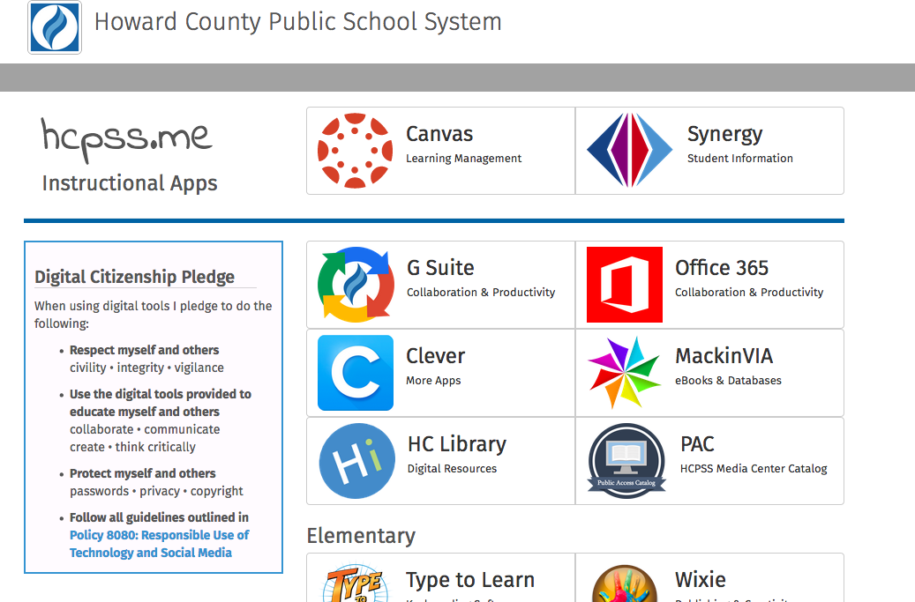

Click on Clever.

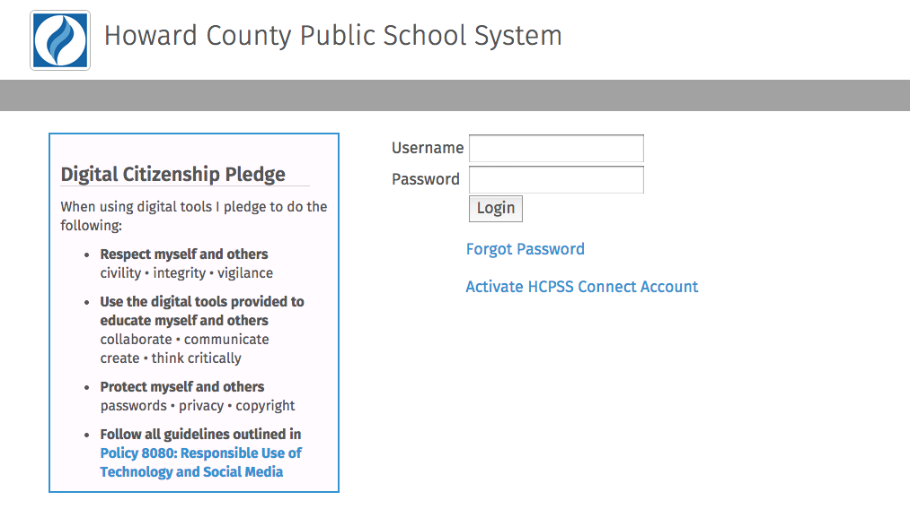

Students’ username and password is the username and password they use to log in to computers at school.

Students are now logged on to Clever and should click the Dreambox icon.

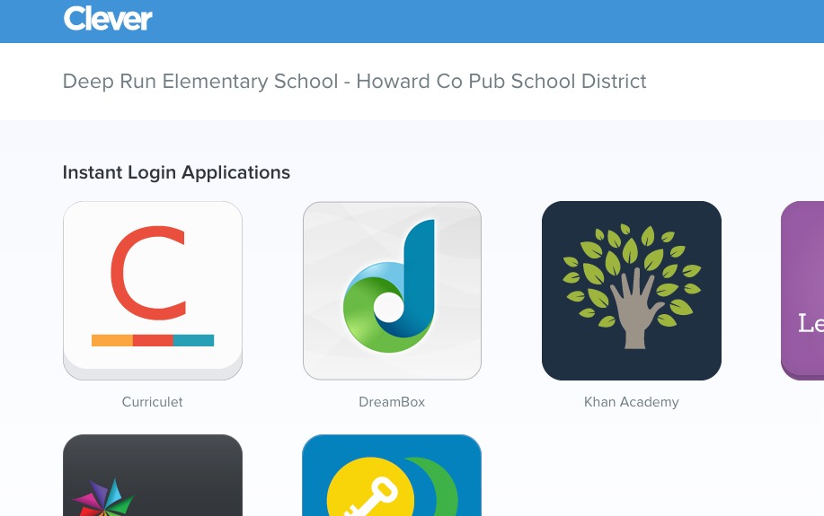

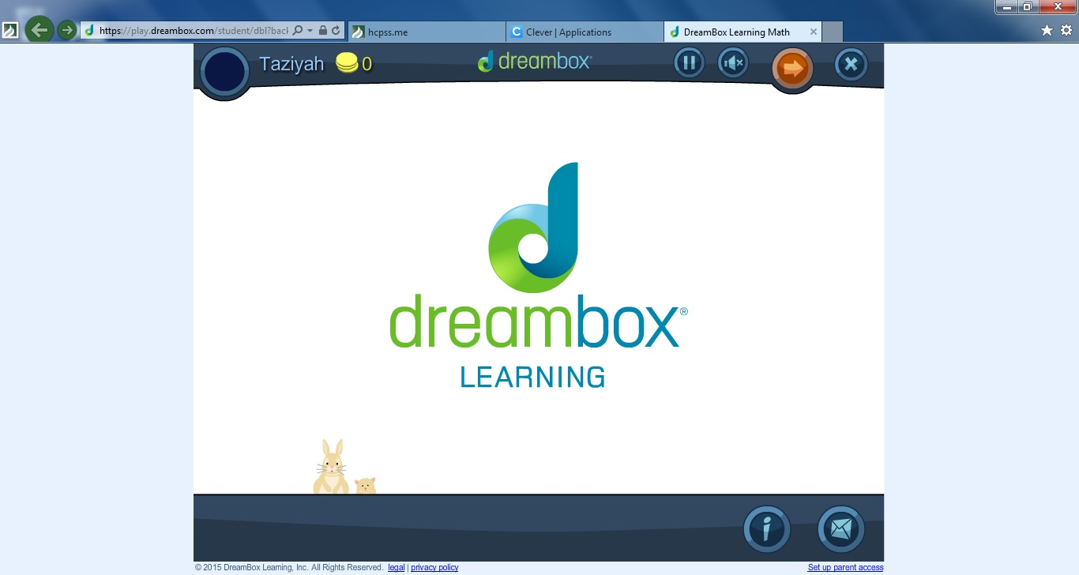

Students are now logged in to Dreambox and ready to go!